**Digital Nurture 4.0 Java FSE**

**Week 7 ReactJS - HOL**

**Mandatory Exercise (HandsOn 11)**

**Exercise 11:** Create a React Application “eventexamplesapp” to handle various events of the form elements in HTML.

1. Create “Increment” button to increase the value of the counter and “Decrement” button to decrease the value of the counter. The “Increase” button should invoke multiple methods.
   1. To increment the value
   2. Say Hello followed by a static message.

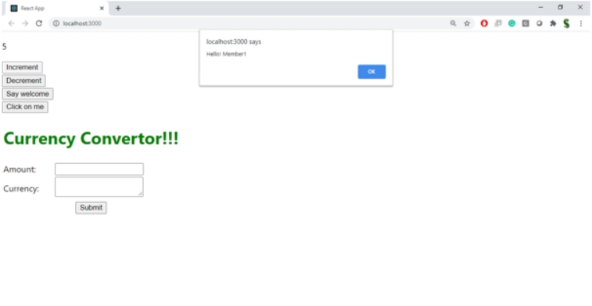

1. Create a button “Say Welcome” which invokes the function which takes “welcome” as an argument.

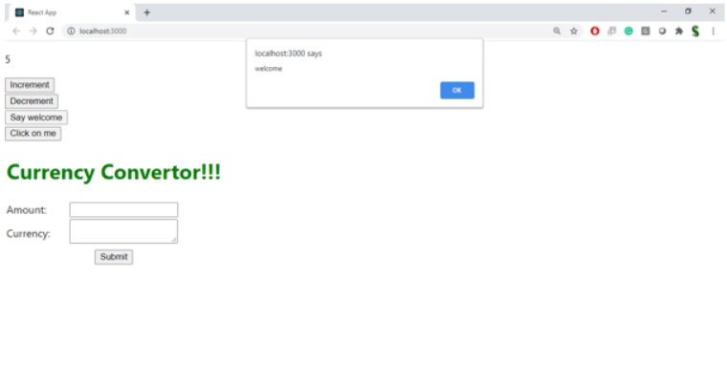

1. Create a button which invokes synthetic event “OnPress” which display “I was clicked”

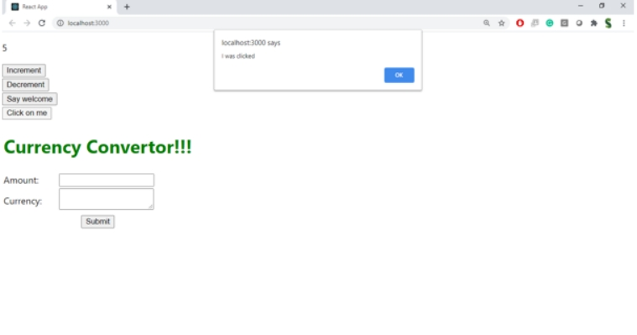Create a “CurrencyConvertor” component which will convert the Indian Rupees to Euro when the Convert button is clicked.

Handle the Click event of the button to invoke the handleSubmit event and handle the conversion of the euro to rupees.

**Answer:**

**App.js:**

import React, { useState } from 'react';

import CurrencyConvertor from './CurrencyConvertor';

function App() {

  const [count, setCount] = useState(0);

// Multiple method handler for "Increment"

  const handleIncrement = () => {

    incrementValue();

    sayHello();

  };

const incrementValue = () => {

    setCount(prev => prev + 1);

  };

const sayHello = () => {

    alert('Hello! Cognizant member .');

  };

const handleDecrement = () => {

    setCount(prev => prev - 1);

  };

// Say Welcome with argument

  const sayWelcome = (message) => {

    alert(message);

  };

// Synthetic event handler

  const handleClick = (e) => {

    alert('I was clicked');

  };

return (

    <div style={{ padding: '20px' }}>

      <h1>Event Examples App</h1>

{/* Counter Buttons */}

      <h2>Counter: {count}</h2>

      <button onClick={handleIncrement}>Increment</button>

      <button onClick={handleDecrement}>Decrement</button>

  {/* Say Welcome */}

      <div style={{ marginTop: '20px' }}>

        <button onClick={() => sayWelcome('Welcome!')}>Say Welcome</button>

      </div>

{/* Synthetic Event */}

      <div style={{ marginTop: '20px' }}>

        <button onClick={handleClick}>Click on me</button>

      </div>

{/* Currency Convertor */}

      <div style={{ marginTop: '40px' }}>

        <CurrencyConvertor />

      </div>

    </div>

  );

}

export default App;

**CurrencyConvertor.js:**

import React, { useState } from 'react';

function CurrencyConvertor() {

  const [rupees, setRupees] = useState('');

  const [euros, setEuros] = useState(null);

const handleSubmit = () => {

    const conversionRate = 0.011; // Example rate: ₹1 = €0.011

    const converted = (parseFloat(rupees) * conversionRate).toFixed(2);

    setEuros(converted);

    alert(`₹${rupees} is approximately €${converted}`);

  };

return (

    <div>

      <h2>Currency Convertor</h2>

      <input

        type="number"

        value={rupees}

        onChange={(e) => setRupees(e.target.value)}

        placeholder="Enter amount in ₹"

      />

      <button onClick={handleSubmit}>Convert</button>

      {euros && <p>Converted Amount: €{euros}</p>}

    </div>

  );

}

export default CurrencyConvertor;

**Output:**

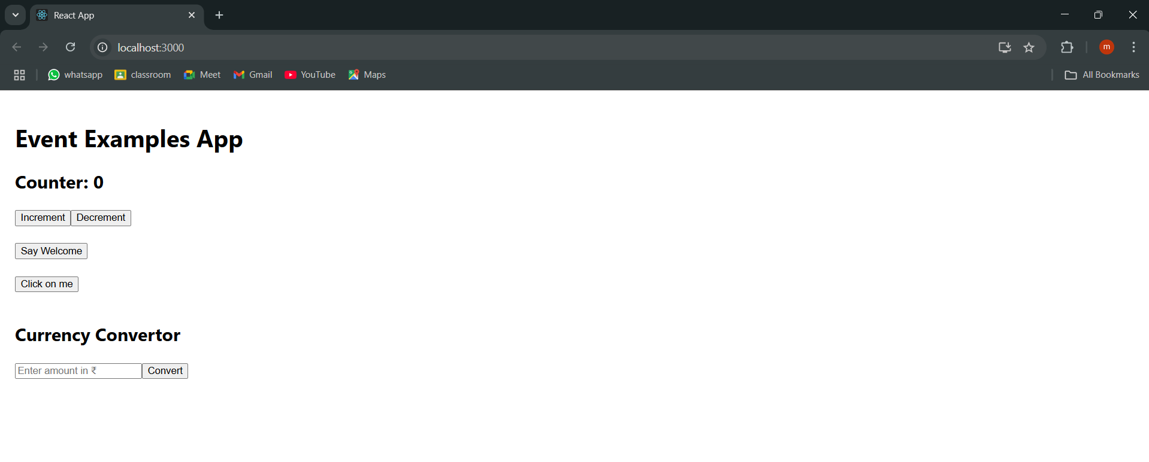

**1.On pressing INCREMENT**

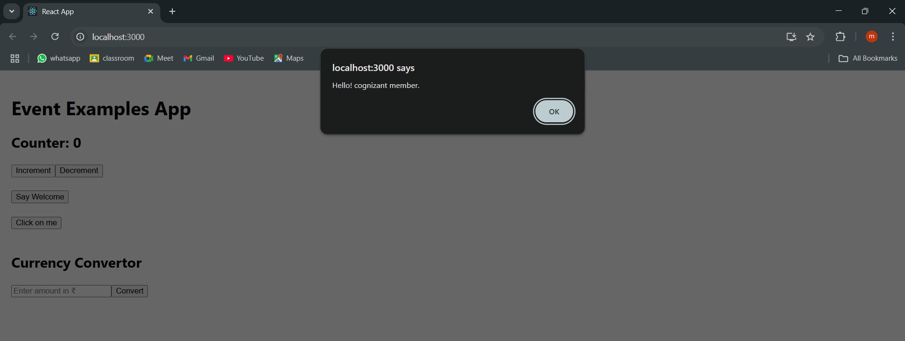

**2.On pressing DECREMENT (Twice)**

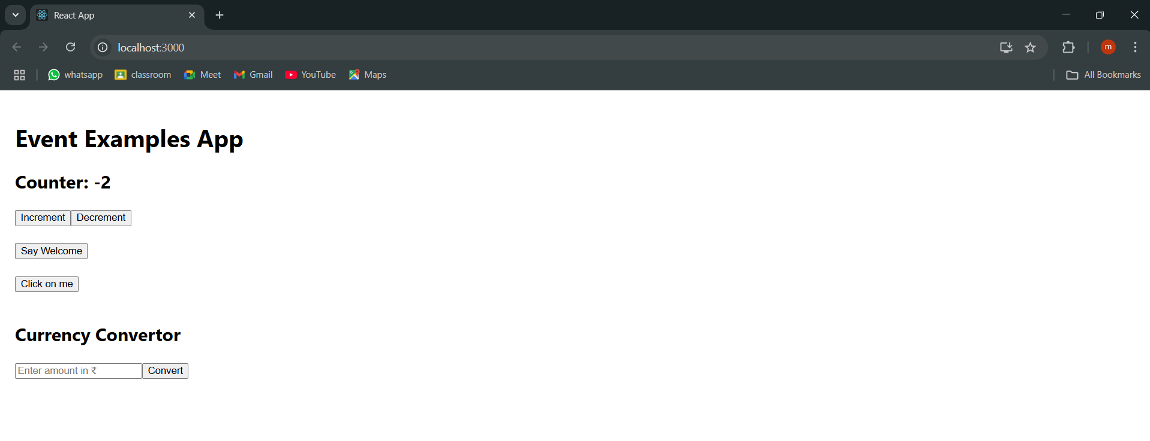

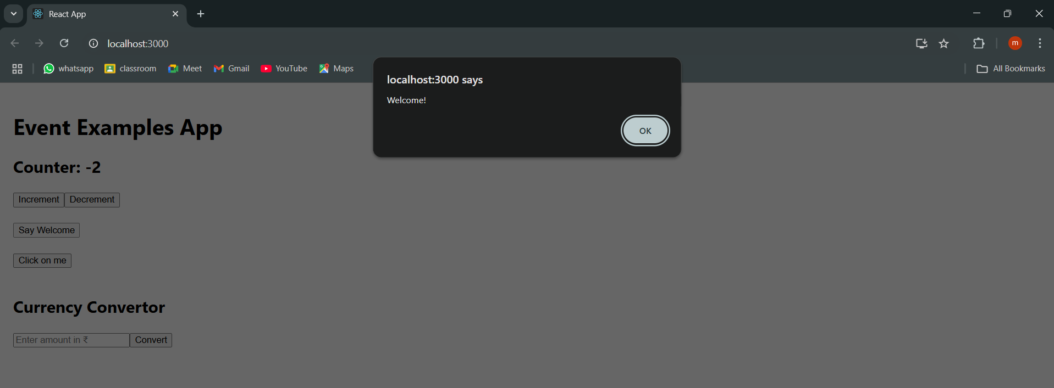**3.On pressing SAY WELCOME**

**4.On pressing CLICK ON ME**

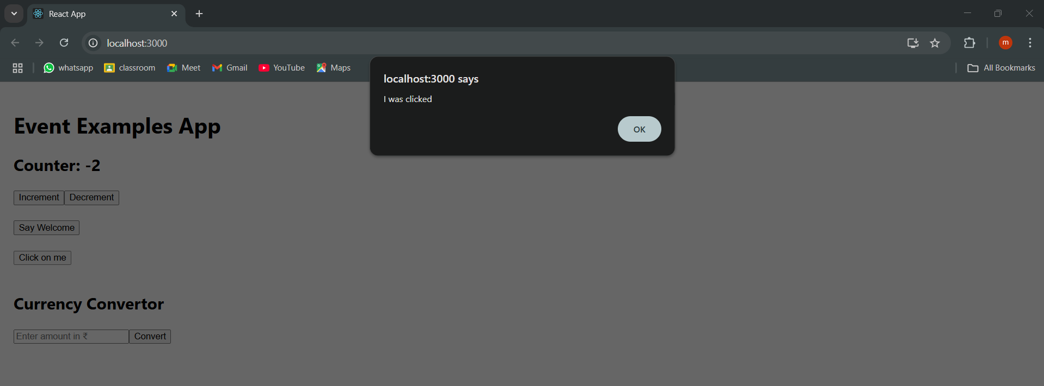

**5.On Entering AMOUNT FOR CONVERTING TO CURRENCY (Euro)**

